**Department of Computer Engineering**

**Academic Term: First Term 2**

Class: T.E /Computer Sem – V / Software Engineering

|  |  |
| --- | --- |
| Practical No: | 6 |
| Title: | Data flow analysis of the Project |
| Date of Performance: | 22/08/2023 |
| Roll No: | 9625 |
| Team Members: | Aditya Dhikale, Mohtashim Ali, Siddhant Murade  (9531) (9644) (9625) |

Rubrics for Evaluation:

Sr.

No

Performance

Indicator

Excellent

Good

Below

Average

Total Score

1

On time Completion

&

Submission (01)

01

(On

Time)

NA

00

(Not on

Time)

2

Theory

Understanding (02)

02(

Correct

)

NA

01

(

Tried

)

3

Content Quality

(03)

03(

All

used)

02

(Partial

)

01

(rarely

followed)

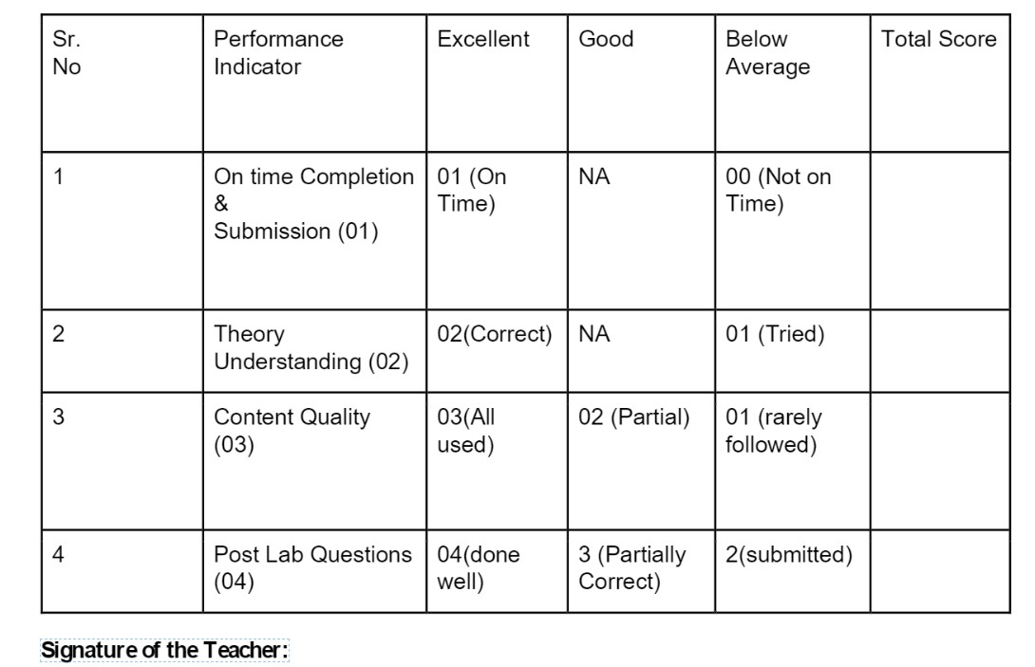

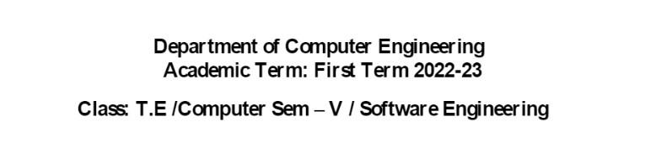

# Lab Experiment 05

**Experiment Name**: Data Flow Analysis of the Project in Software Engineering

**Objective:** The objective of this lab experiment is to introduce students to Data Flow Analysis, a technique used in software engineering to understand the flow of data within a software system. Students will gain practical experience in analyzing the data flow of a sample software project, identifying data dependencies, and modeling data flow diagrams.

**Introduction:** Data Flow Analysis is a vital activity in software development, helping engineers comprehend how data moves through a system, aiding in identifying potential vulnerabilities and ensuring data integrity.

**Lab Experiment Overview:**

1. Introduction to Data Flow Analysis: The lab session begins with an overview of Data Flow Analysis, its importance in software engineering, and its applications in ensuring data security and accuracy.
2. Defining the Sample Project: Students are provided with a sample software project, which includes the data elements, data stores, processes, and data flows.
3. Data Flow Diagrams: Students learn how to construct Data Flow Diagrams (DFDs) to visualize the data flow in the software system. They understand the symbols used in DFDs, such as circles for processes, arrows for data flows, and rectangles for data stores.
4. Identifying Data Dependencies: Students analyze the sample project and identify the data dependencies between various components. They determine how data is generated, processed, and stored in the system.
5. Constructing Data Flow Diagrams: Using the information gathered, students create Data Flow Diagrams that represent the data flow within the software system. They include both high-level context diagrams and detailed level-0 and level-1 diagrams.
6. Data Flow Analysis: Students analyze the constructed DFDs to identify potential bottlenecks, inefficiencies, and security vulnerabilities related to data flow.
7. Conclusion and Reflection: Students discuss the significance of Data Flow Analysis in software development and reflect on their experience in constructing and analyzing Data Flow Diagrams.

**Learning Outcomes**: By the end of this lab experiment, students are expected to:

* + Understand the concept of Data Flow Analysis and its importance in software engineering.
  + Gain practical experience in constructing Data Flow Diagrams to represent data flow in a software system.



* + Learn to identify data dependencies and relationships within the software components.



* + Develop analytical skills to analyze Data Flow Diagrams for potential issues and vulnerabilities.
  + Appreciate the role of Data Flow Analysis in ensuring data integrity, security, and efficiency.

**Pre-Lab Preparations:** Before the lab session, students should familiarize themselves with Data Flow Analysis concepts and the symbols used in Data Flow Diagrams. They should review data dependencies and data flow modeling in software systems.

**Materials and Resources:**

* + Project brief and details for the sample software project



* + Whiteboard or projector for constructing Data Flow Diagrams
  + Drawing tools or software for creating the diagrams

**Conclusion:** The lab experiment on Data Flow Analysis of a software project equips students with essential skills in understanding data flow within a system. By constructing and analyzing Data Flow Diagrams, students gain insights into how data is processed, stored, and exchanged, enabling them to identify potential issues and security concerns. The practical experience in Data Flow Analysis enhances their ability to design efficient and secure software systems that ensure data integrity and meet user requirements. The lab experiment encourages students to apply Data Flow Analysis in real- world software development projects, promoting better data management and system design practices.

**Data Flow of Online shopping Website:**

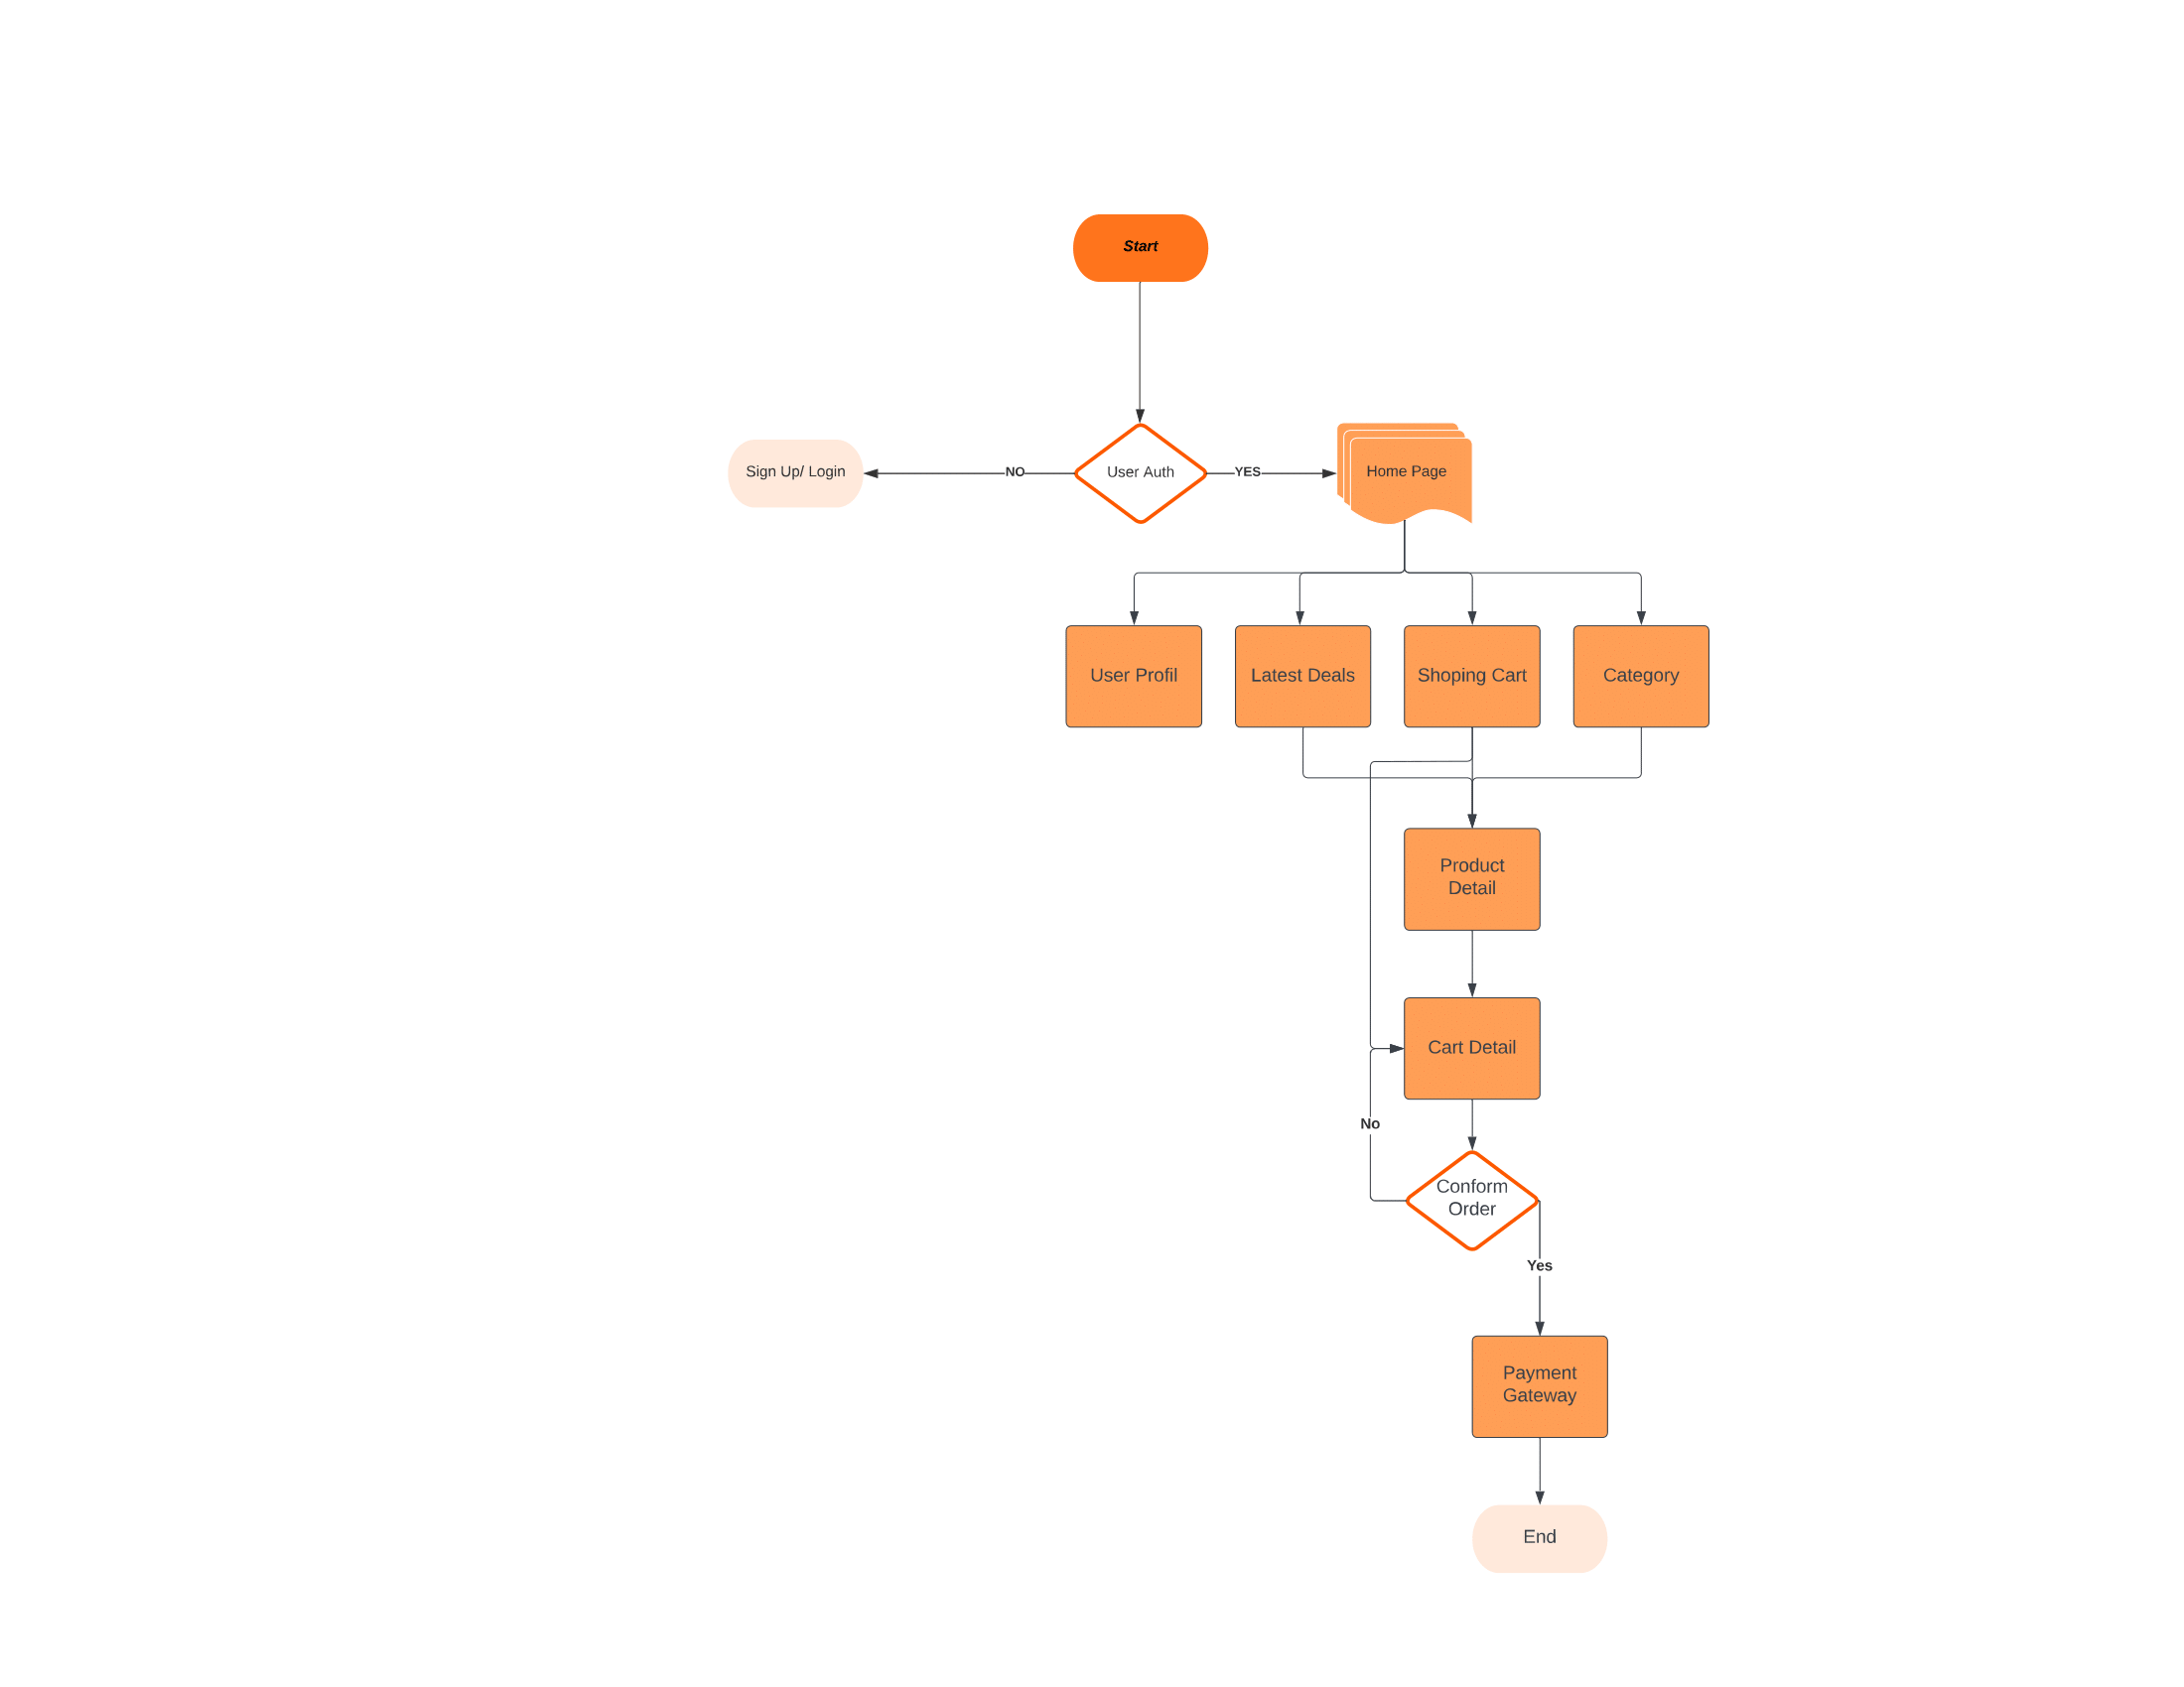

**Postlabs**

**Q1.** Evaluate the benefits of using Data Flow Diagrams (DFD) to analyze and visualize the data movement in a complex software system?

**ANS:** Data Flow Diagrams (DFDs) offer several benefits when used to analyze and visualize data movement in a complex software system:

Clarity and Simplicity: DFDs provide a clear and concise way to represent complex systems. They use simple symbols and notations to illustrate how data flows within the system, making it easier for both technical and non-technical stakeholders to understand.

Visualization of Data Flow: DFDs offer a visual representation of how data moves through different parts of the system. This visualization helps in identifying potential bottlenecks, dependencies, and inefficiencies in data processing.

Structured Analysis: DFDs encourage a structured approach to system analysis. They break down the system into manageable processes and data stores, allowing for a systematic examination of each component's function and interaction.

Communication: DFDs serve as a communication tool between different stakeholders involved in system development. They facilitate discussions and collaboration among designers, developers, and users, ensuring that everyone has a shared understanding of the system.

Scalability: DFDs are scalable, meaning you can create different levels of abstraction. You can start with a high-level overview of the entire system and then progressively add more detail as needed. This flexibility makes them suitable for both high-level planning and detailed design phases.

Change Management: When system requirements change, DFDs can be easily updated to reflect these changes. This adaptability helps in managing and documenting the evolution of the system over time.

Identification of Data Transformation: DFDs highlight the transformations applied to data as it flows through the system. This is crucial for understanding how data is processed, modified, or converted at different stages.

Error Detection: By analyzing DFDs, you can identify potential error points in the data flow. This aids in designing error-handling mechanisms and ensuring data integrity.

Documentation: DFDs serve as valuable documentation for the system. They provide a reference point for future maintenance and troubleshooting activities.

Integration Planning: DFDs can help in planning the integration of different system components or third party services. They allow you to assess how data will flow between these elements.

In summary, Data Flow Diagrams are a powerful tool for analyzing and visualizing data movement in complex software systems. They promote clarity, communication, and structured analysis, making them invaluable in system design, development, and maintenance processes.

**Q2.** Apply data flow analysis techniques to a given project and identify potential data bottlenecks and security vulnerabilities?

**ANS**: To apply data flow analysis techniques to a given project and identify potential data bottlenecks and security vulnerabilities, you would typically follow these steps:

Understand the Project: Begin by thoroughly understanding the project's objectives, requirements, and architecture. Gather relevant documentation and talk to stakeholders to gain insights into how data flows within the system.

Create Data Flow Diagram (DFD): Construct a DFD for the project. Start with a high-level context diagram to depict the main data inputs and outputs. Then, create more detailed DFDs for different subsystems or modules.

Identify Data Sources and Destinations: In the DFDs, pinpoint the sources of data (e.g., user input, external systems, databases) and where it's consumed or stored (e.g., databases, files, outputs). This helps you track the flow of data.

Trace Data Flow: Follow the paths of data through the system, considering all possible routes and transformations. Look for areas where data might bottleneck due to high volume or inefficient processing.

Identify Security Controls: Assess the security measures in place, such as authentication, authorization, encryption, and auditing. Determine if there are potential vulnerabilities in these controls or areas where sensitive data might be exposed.

Analyze Data Validation: Check how data is validated and sanitized at various points in the system.

Identify places where inadequate validation or sanitization could lead to data integrity or security issues.

Consider Data Storage: Evaluate how data is stored and accessed within the system. Look for vulnerabilities related to data storage, such as insecure databases, inadequate backup procedures, or exposure of sensitive data.

Check Data Transmission: Examine how data is transmitted between different components, especially if it involves network communication. Assess encryption protocols, secure channels, and potential interception points.

Review Third-party Integrations: If the project involves third-party integrations, assess the security of these connections and how they handle data. Ensure that data exchanged with external systems is adequately protected.

Performance Analysis: For data bottlenecks, analyze system performance metrics to identify areas where data processing or transfer is causing delays. This could involve profiling the system to pinpoint performance bottlenecks.

Risk Assessment: Assign risk levels to identified issues, considering their potential impact and likelihood.

Prioritize addressing high-risk items that could have severe consequences.

Recommendations: Finally, based on your analysis, provide recommendations for mitigating data bottlenecks and security vulnerabilities. These may include architectural changes, code modifications, security enhancements, or improved data handling practices.

It's essential to conduct ongoing monitoring and testing of the project to ensure that the identified vulnerabilities are addressed and that new issues are promptly identified and resolved. Data flow analysis is an iterative process that should be integrated into the project's development lifecycle to maintain a secure and efficient system.

**Q3.**Propose improvements to the data flow architecture to enhance the system's efficiency and reduce potential risks?

**ANS:** To propose improvements to the data flow architecture to enhance the system's efficiency and reduce potential risks, consider the following strategies:

Data Compression and Optimization:

Implement data compression techniques to reduce the volume of data transferred, especially over networks.

Optimize data structures and algorithms to minimize memory and processing requirements.

Caching:

Introduce caching mechanisms to store frequently accessed data, reducing the need to retrieve it from the source repeatedly.

Employ caching strategies like Least Recently Used (LRU) or Time-based caching to manage cached data efficiently.

Load Balancing:

Distribute incoming data loads evenly across multiple servers or components to prevent overloading any single element.

Use load balancing algorithms to ensure efficient resource utilization.

Parallel Processing:

Implement parallel processing to handle data tasks concurrently, improving system throughput.

Identify tasks that can be parallelized and design the architecture to support this.

Asynchronous Processing:

Use asynchronous processing for non-blocking operations, allowing the system to continue processing other tasks while waiting for slow I/O operations or external services.

Implement message queues or event-driven architectures for handling asynchronous tasks.

Data Validation and Sanitization:

Strengthen data validation and sanitization procedures to prevent data corruption or security vulnerabilities.

Employ input validation libraries and practices to ensure data integrity.

Distributed Architecture:

Consider a distributed architecture that spans multiple servers or cloud resources to improve scalability and fault tolerance.

Implement microservices or serverless architecture for better resource management.

Security Enhancements:

Implement robust security measures such as encryption, authentication, and authorization at every data interaction point.

Regularly update security protocols and conduct security audits to identify vulnerabilities.

Monitoring and Analytics:

Integrate monitoring and analytics tools to track data flow, system performance, and potential bottlenecks in real-time.

Set up alerts to notify administrators of anomalies or issues.

Error Handling:

Improve error handling mechanisms to gracefully handle unexpected situations without system failure.

Implement proper logging and error reporting for debugging and troubleshooting.

Documentation and Training:

Maintain comprehensive documentation for the data flow architecture to aid in troubleshooting and onboarding new team members.

Provide training to staff on best practices for data handling and security.

Scalability Planning:

Develop a scalability plan that outlines how the system can grow to accommodate increasing data volumes and user loads.

Regularly review and adjust the plan as needed.

Regular Testing and Optimization:

Continuously test and profile the system's performance to identify bottlenecks and areas for improvement.

Optimize the architecture based on performance data and user feedback.

Remember that system improvements should be implemented incrementally and rigorously tested to ensure they have the desired impact without introducing new issues. Additionally, involving cross functional teams, including developers, system administrators, and security experts, is essential for successful architecture enhancements and risk reduction.